**Software Engineering Challenge**

**Requirements**

Describe the challenge or problem, what does the program need to do  
create a cyberpunk cityscape with the city sky transitioning from darkness to lights turning on

What classes/objects do you think you need?

Cars, buildings, train, train station, lake

How much time do you think you will you need to complete the project?

1 week

**Research**

What knowledge or skills will you need to build this program

* Math knowledge to create certain shapes/lines
* How to animate objects on a frame using threads and methods
* How to create objects for each component on the frame
* How to animate an imported picture

Do you foresee any problems or constraints, describe

* Time constraint (lots of extracurricular activities outside of class)
* How to animate rain

Have you created a similar programs? Are there similar programs in the book or other resources?

No, I haven’t made a similar program. The resources are the notes we took in class.

If so, what elements of that project can you bring to this project?

Do you have the resources you need to create the program?

Yes

Do you need to learn any new knowledge or skill(s) to create the program?

No

**Design**

Draw/create a basic graphic you plan to build - attach the drawing

(paint, word, photo shop) not every objet (draw one example although there may be several in the final program) needs to be in the basic graphic

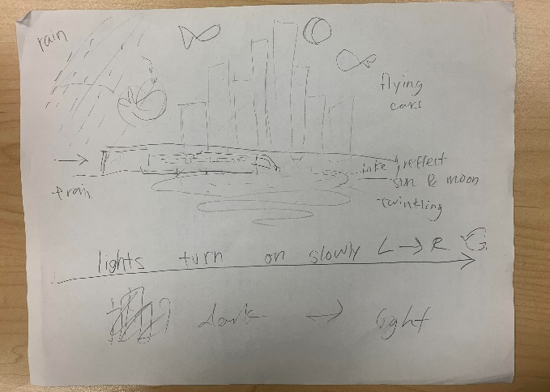

Include a task list--what will you need to do and in what order

* Foreground first: Create building class that can create other different building objects, changing lights
* Create lake class that will have waves, reflecting and changing lights
* Create train class that will have train moving across screen (changing lights)
* create car class that will have cars fly across the screen, changing lights
* create rain

Estimate the amount of time you will need to complete each part the project

* 5 class days

**Construction – included in summary doc**

Document your construction progress with date and progress made (build a chart/table in word or excel), also, include at least three screen shots of your city (beginning, middle, and end)

**Testing/Results/Delivery—summary doc not required to start project**

Preliminary testing

Does your program meet the needs of the initial challenge or problem? How do you know?

Are any changes or modifications needed, why or why not? Document any changes.

Summarize the project - what worked, what didn’t work, note your successes and/or failures.

Looking back, would you have done anything differently, why or why not

Software Summary Document

Daily Progress Report

|  |  |
| --- | --- |
| Date | Description |
| Jan 12 |  |
| Jan 13 |  |
| Jan 16 | * Create sky and lake, and more buildings |
| Jan 16 | * Locked frame * Added subway |
| Jan 17 | * Added transparent pic of train |
| Jan 18 | * Animate train * Resize buildings |